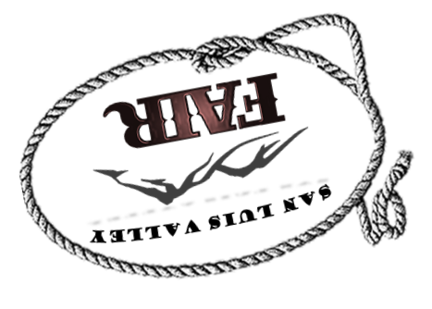
EDUCATIONAL/4-H/FFA
VENDOR APPLICATION
For the
2023 SLV FAIR
August 5th through August 12th
Ski Hi Park
Monte Vista, CO 81144
No Registration Fee

ORGANIZATION/COMPANY CONTACT PERSON
ADDRESS CITY STATE ZIP
PHONE # E-MAIL ADDRESS
TYPE OF BOOTH
PRODUCT DESCRIPTION _____
BOOTH SIZE REQUESTED:☐10x10☐10x20☐OTHER LOCATION:☐INDOOR☐OUTDOOR
NOTICE:
Check In: Thursday August 5th 8 am – 1 pm
Tear down: Friday August 12th any time AFTER 2 pm

DEADLINE: Please turn in completed no later than July 23^{th,} 2023.
Make Checks or Money Orders payable to: SLV FAIR BOARD.
Mail To: SLV Fair Board
PO Box 54
Monte Vista, CO 81144

FOR INFORMATION: Please visit our website www.slvfair.com or email us at sanluisvalleyfair@gmail.com
PARTICIPATION AGREEEMENT
If application is approved the vendor name above agrees to participate during the 2023 SLV Fair and will be responsible for all booth fees. I understand that once I sign this agreement, my booth fees will NOT be refunded if I am unable to participate.
Printed Name:
Vendors Signature: Date:

Thank you for your support on behalf of the SLV Fair Board

